Screenshots of all possible exceptions

# DBConcurrencyException

Triggered by trying to update the same record value at two places.

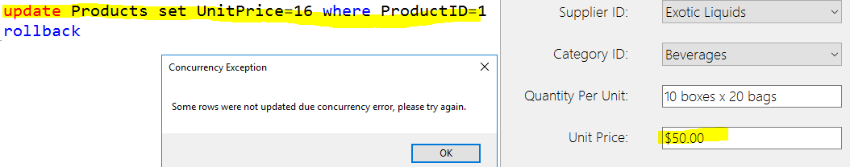

# DataException (includes NoNullAllowedException)

Triggered by trying to insert null value into not null allowed column.

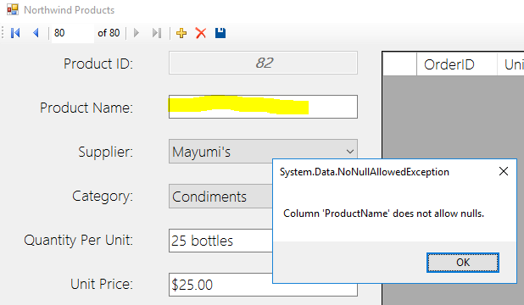

# SqlException (unable to load table -- timeout)

Triggered by trying to load data from a dropped table.

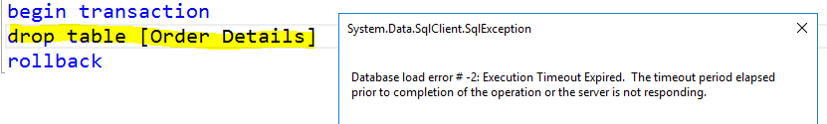

# SqlException (conflict with constraint)

Triggered by trying to insert negative unit price.

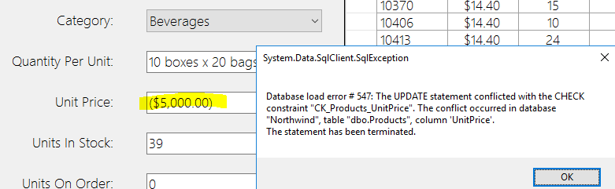

# Other Exception

Triggered by trying to insert data exceeded maximum length of a column.

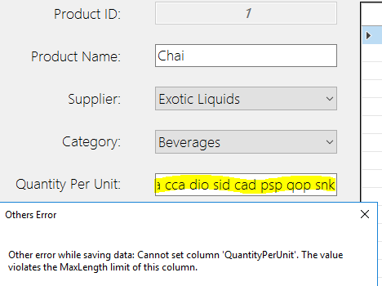

# Self-defined errors

Triggered by trying to type letter or symbol in Units In Stock field,

